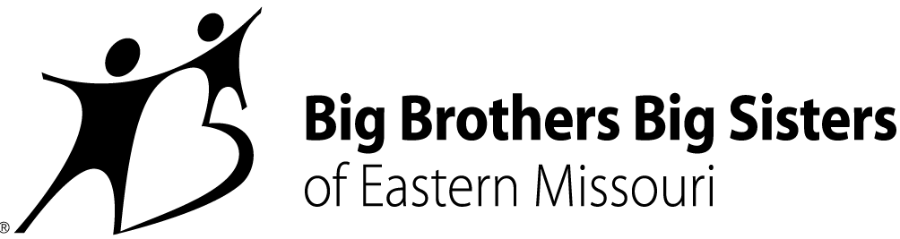

CONTACT:
Misty Willinger
Big Brothers Big Sisters of Eastern Missouri
Office: 314-633-0030
mwillinger@bbbsemo.org
Miya Norfleet-Aiken
Big Brothers Big Sisters of Eastern Missouri
Office: 314-615-1094
Mobile: 314-255-3444
media@bbbsemo.org

BIG BROTHERS BIG SISTERS OF EASTERN MISSOURI HOSTS FIRST 2019 JOB FAIR
FOR CURRENT OPENINGS AND FUTURE EMPLOYMENT OPPORTUNITIES
St. Louis – January 8, 2019 – Following up on two fall 2018 events inviting the public to explore work opportunities, Big Brothers Big Sisters of Eastern Missouri (BBBSEMO) will host its first job fair of 2019 at its St. Louis headquarters on Monday, January 14.
The hour-long session will provide background on BBBSEMO, which encompasses offices serving St. Louis City and County, St. Charles, and Cape Girardeau. Q&A with the agency’s chief programs and operations officers will be included at the event designed for job-seekers wanting to learn more about BBBSEMO’s work serving young people, ages 5-25, through traditional 1:1 matches and innovative, BBBSEMO-pioneered programming.
“We are committed to supporting all our youth, families, and mentors with the very best,” says Rebecca (Becky) J. Hatter, agency President and CEO. “Opening our doors to folks already fired up to help change lives through relationship and to make that part of their everyday work life seems like a wonderful way to build our team at BBBSEMO, both now and in the coming year.”
BBBSEMO, named Agency of the Year in the past year, is looking to fill current and future openings (e.g., Match Relationship Support, Child and Family Enrollment, College and Career Advising, Grant Management, Project Management, Volunteer Recruitment). Positions come with competitive salaries, 100% health coverage, and 100% long- and short-term disability. Other benefits include flexible work schedules and generous holiday schedules.
BBBSEMO’s January 2019 job fair takes place Monday, January 14, from 5:30-6:30pm at the Big Brothers Big Sisters building 501 North Grand Blvd., St. Louis, MO, 63103. For more details about immediate openings and agency culture and values, visit http://www.bbbsemo.org/about/careers/.
About Big Brothers Big Sisters of Eastern Missouri (BBBSEMO)
Big Brothers Big Sisters of Eastern Missouri, founded in 1914 as a “charter” affiliate of Big Brothers Big Sisters of America, is guided by the principle that “In relationship, young people grow up with love, hope, and opportunity.” BBBSEMO’s approach includes five key elements: Create trusting, enduring relationships between young people (ages 5-25) and adult role models, mentors, and advocates; support academic success kindergarten to career; promote health and well-being; host life-skills training and development; coordinate temporary resources to support youth, parents, and families. The agency supports children and families in St. Louis City and County; St. Charles and Jefferson Counties; and Cape Girardeau and Scott Counties. Big Brothers Big Sisters of Eastern Missouri is a proud member of the United Way. For more information, contact Miya Norfleet (email - media@bbbsemo.org, phone - (314) 615-1094) or visit www.bbbsemo.org.

