CONTACT:
Misty Willinger
Big Brothers Big Sisters of Eastern Missouri
Phone: 417-207-0112
mwillinger@bbbsemo.org

Miya Norfleet-Aiken
Big Brothers Big Sisters of Eastern Missouri
Office: 314-615-1094
Mobile: 314-255-3444
media@bbbsemo.org

Big Brothers Big Sisters of Eastern Missouri
Launches New Initiative Focused on Recruiting First Responders to Be Mentors
St. Louis – June 13, 2019 – Big Brothers Big Sisters of Eastern Missouri (BBBSEMO), a nationally-recognized leader in youth mentorship programs, today announced its launch of Big Responders, a new recruitment initiative aimed at adding first-response professionals to its ranks of one-to-one youth mentors. Powered by partnerships with departments and agencies throughout the St. Louis region, Big Responders will focus on reaching firefighters, paramedics, law enforcement officers, and other emergency responders ready to support community both in and out of uniform.
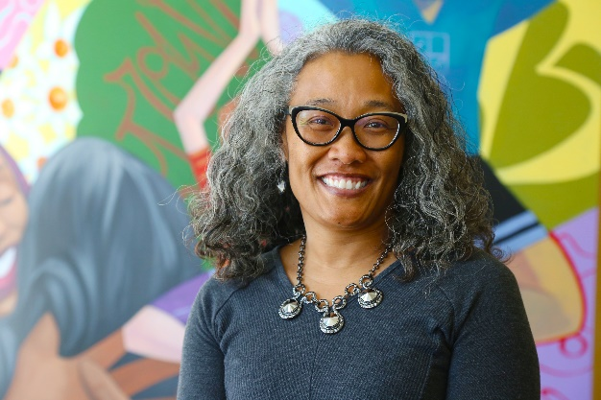
President and CEO Rebecca (Becky) J. Hatter says this new initiative expands an existing BBBSEMO “original” called Bigs in Blue, a program adopted by Big Brothers Big Sisters affiliates across the country in 2016. By encompassing all first responders, Hatter says that “Big Responders will allow us to recruit more mentors, creating more meaningful relationships between young people and community, and open up the possibility for more unique experiences.”
Big Responders efforts in 2019 will be led by BBBSEMO’s new Director of Volunteer Recruitment, Linda Robinson. Robinson, with the support of respected leaders from St. Louis first-response agencies – Dr. Dan Isom, former SLMPD Chief and current Executive Director of REJIS; Captain Ron Johnson, retired Missouri Highway Patrol; Lieutenant Latricia Allen, SLMPD; and Deputy Chief Cliff Robinson, Florissant Valley Fire Protection District – will partner with BBBSEMO staff and other community members to recruit more volunteers to serve as Big Brothers and Big Sisters.

“It is important to partner with great influencers like these,” says Robinson, “because they are advocates for BBBS who understand community, especially the children, and can empower others to become who they want to be in life.”
Like all mentoring programs supported by Big Brothers Big Sisters of Eastern Missouri, Big Responders aims to ensure that children and teenagers grow up with love, hope, and opportunity. To fulfill this vision, young people must be surrounded by caring and consistent adults. The first several months’ goal for the Big Responders campaign is recruiting 15 new first responders by the end of 2019 to serve as one-to-one mentors to youth in their service communities.
The Big Responders initiative maintains BBBSEMO’s commitment to young people with hopes of deepening relationships between first responders and the community members they serve. According to Hatter, “There is no program that really changes the hearts and minds of individuals; it is relationships that change lives.”
Big Brothers Big Sisters appreciates the ongoing support of the community, which enables it to grow its services to children. The agency gives special thanks to the new initiative’s Signature Sponsor, Propper.
“Propper is honored to be a signature sponsor of the Big Responders program,” said John Negrau, Vice President of Marketing & eCommerce for Propper. “This is one more way to continue serving those who serve.”
To learn more about the program and becoming involved, contact Linda Robinson at (314) 633-0024.
To become a sponsor of Big Responders, contact Becky Hatter at (314) 361-5900.
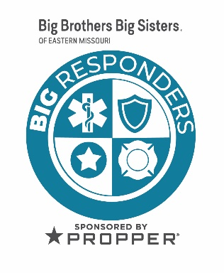
About Big Brothers Big Sisters of Eastern Missouri (BBBSEMO)
Big Brothers Big Sisters of Eastern Missouri, founded in 1914 as a “charter” affiliate of Big Brothers Big Sisters of America, is guided by the principle that “In relationship, young people grow up with love, hope, and opportunity.” BBBSEMO’s approach includes five key elements: Create trusting, enduring relationships between young people (ages 5-25) and adult role models, mentors, and advocates; support academic success kindergarten to career; promote health and well-being; host life-skills training and development; coordinate temporary resources to support youth, parents, and families. The agency supports children and families in St. Louis City and County; St. Charles and Jefferson Counties; and Cape Girardeau and Scott Counties. Big Brothers Big Sisters of Eastern Missouri is a proud member of the United Way. For more information, contact Miya Norfleet (email: media@bbbsemo.org; 314-615-1094) or visit www.bbbsemo.org.
About Propper
Propper has made tactical gear with a purpose for over 50 years, since their first U.S. Navy contract in 1967. Today, Propper designs and manufactures professional level tactical apparel and gear for military, law enforcement, public safety professionals, and civilians whether they’re in the service, on the job, or off for the weekend.
For more information (press only), contact David Workman (davidw@propper.com; 636-685-1062). For more information on Propper visit Propper.com

