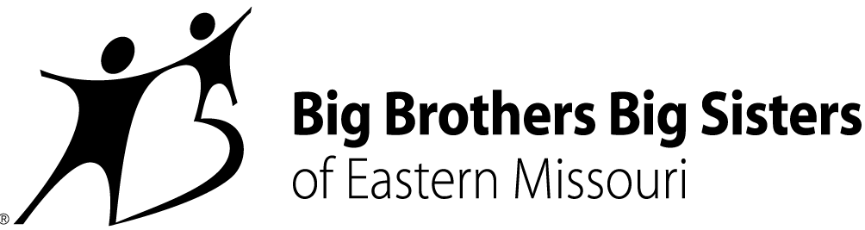

CONTACT:
Misty Willinger
Big Brothers Big Sisters of Eastern Missouri
Phone: 417-207-0112
mwillinger@bbbsemo.org

Miya Norfleet-Aiken
Big Brothers Big Sisters of Eastern Missouri
Office: 314-615-1094
Mobile: 314-255-3444
media@bbbsemo.org

BIG BROTHERS BIG SISTERS OF EASTERN MISSOURI MENTORS SELECTED FOR STATEWIDE HONORS AS AGENCY WELCOMES NEW DIRECTOR OF RECRUITMENT
St. Louis – April 16, 2019 – Two mentors matched through Big Brothers Big Sisters of Eastern Missouri (BBBSEMO) have been named the state’s Big Brother and Big Sister of the Year. The announcement comes the same month BBBSEMO has added a new director of volunteer recruitment to its staff.
Adam Rockey and Megan Garza were among several Missouri nominees considered by a committee representing all five (5) Big Brothers Big Sisters affiliates in the Show Me State. The award puts them among the ranks of preceding agency standouts: just last year, BBBSEMO’s Lauren Bauer and Leo Peoples III were named Big Sister and Big Brother of the Year for all of Missouri.
The “Bigs” honored this year – matched a combined 18.5+ years with their respective “Littles” – highlights two ingredients key to every lasting Big Brothers Big Sisters relationship: teamwork and commitment.
“When Adam and Megan heard they were our agency’s Bigs of the Year, both credited their Littles immediately,” says Rebecca (Becky) J. Hatter, CEO and President of BBBSEMO. “That not only shows humility, it also reveals how much each loves and respects their Little, and how much Johnathan and Angel mean in their Bigs’ lives.”
“Angel and I were so excited to get the news,” shared Big Sister Megan in an email. “With so many awesome Big Sisters across the state, this is quite an honor… it’s a privilege to be in their company. One friend called it a ‘good human’ award… I think that was my favorite reaction.”
Big Brother Adam and Little Brother Johnathan shared excitement, too, along with “a celebratory pizza.”
“It's an incredible honor to represent the top agency in the country as their Big of the Year!” Big Brother Adam wrote. “The recognition at the state level is the whip cream on the cupcake!”
These Bigs’ dedication mirrors – and drives – BBBSEMO’s continued work to match more of the +1,000 Eastern Missouri youth waiting for a Big Brother, Big Sister, Big Couple, or Big Family. The award-winning agency, named Large Agency of the Year in 2018, has stepped up its efforts around that work by enlisting longtime St. Louisan and community advocate Linda Robinson to serve as its new Director of Volunteer Recruitment.
Robinson’s 28-year career in the financial sector featured volunteerism on- and off the clock. She comes to BBBSEMO after 10 years with Wells Fargo Advisors eager to meet prospective Bigs and raise awareness of the long-range benefits of mentoring enjoyed by youth and adults alike.
“Volunteering gives back to community in a way that no monetary donation can give,” Robinson says. “I’m excited to build new relationships and encourage people to give their time, talent, and treasure with passion and purpose.”
About Big Brothers Big Sisters of Eastern Missouri (BBBSEMO)
Big Brothers Big Sisters of Eastern Missouri, founded in 1914 as a “charter” affiliate of Big Brothers Big Sisters of America, is guided by the principle that “In relationship, young people grow up with love, hope, and opportunity.” BBBSEMO’s approach includes five key elements: Create trusting, enduring relationships between young people (ages 5-25) and adult role models, mentors, and advocates; support academic success kindergarten to career; promote health and well-being; host life-skills training and development; coordinate temporary resources to support youth, parents, and families. The agency supports children and families in St. Louis City and County; St. Charles and Jefferson Counties; and Cape Girardeau and Scott Counties. Big Brothers Big Sisters of Eastern Missouri is a proud member of the United Way. For more information, contact Miya Norfleet (email - media@bbbsemo.org, phone - (314) 615-1094) or visit www.bbbsemo.org.

