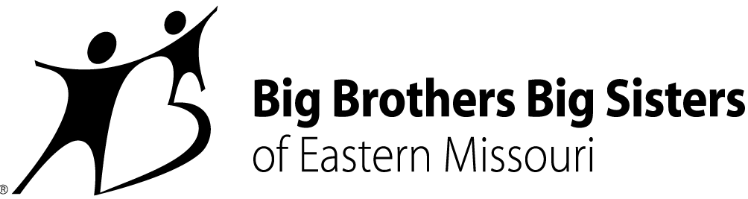

CONTACT:
Misty Willinger
Big Brothers Big Sisters of Eastern Missouri
Phone: 417-207-0112
mwillinger@bbbsemo.org
Miya Norfleet-Aiken
Big Brothers Big Sisters of Eastern Missouri
Office: 314-615-1094
Mobile: 314-255-3444
media@bbbsemo.org

BIG BROTHERS BIG SISTERS OF EASTERN MISSOURI EMBRACES GRADUATES AND THEIR NEXT STEPS WITH “OWN THE FUTURE” CELEBRATION
St. Louis – April 2, 2019 – To recognize the accomplishments of its high school seniors and older-teen “Littles” and welcome them to a new support network, Big Brothers Big Sisters of Eastern Missouri (BBBSEMO) will host the “Own the Future” event later this week at the newly-revitalized Hotel St. Louis in downtown St. Louis.
BBBSEMO serves over 1,800 Littles across Eastern Missouri. “Own the Future,” which inaugurates a series of agency events celebrating Littles at different stages, will focus on the 92 young people ‘graduating’ from Big Brothers Big Sisters’ 1:1 mentoring program. The April 5th event will also introduce “alumni Littles” to a new phase of relationship with BBBSEMO: Big Futures – a program created by BBBSEMO to extend its promise to Be There for alumni through age 25.
“Standing with our Littles’ Bigs and families to applaud their achievements is fantastic on its own,” says Tashanna Rucker, Senior Director of Big Futures. “Getting to welcome them to Big Futures and provide support as they pursue further education, military service, and living wage work is an exciting bonus.”
The evening will include guest speaker Travis Sheridan, President of CIC Venture Café Global Institute, Inc. and founding Executive Director of Venture Café Foundation – St. Louis. Kennedy Holmes, a finalist in “The Voice” – Season 15, will bring a special performance to the night’s program.
Rebecca (Becky) J. Hatter, BBBSEMO’s President and CEO, says the “Own the Future” event speaks to celebration and elevation, two themes partially inspired by BBBSEMO’s Agency of the Year award last June and this coming June’s Big Futures anniversary .
“It’s no accident that we’re taking this fresh approach to our Littles’ graduation the same year Big Futures turns five,” says Hatter, noting that 320 alumni Littles with BBBSEMO have been part of the post-high school-age program. “Cheering for every graduate, their triumphs and welcoming them into Big Futures is a pledge – to support their growth, and to keep growing with them ourselves.”
“Own the Future” takes place Friday, April 5, from 6:00-8:00pm. For more about the event, contact Misty Willinger at mwillinger@bbbsemo.org or 417-207-0112; for more about Big Futures, contact Tashanna Rucker at trucker@bbbsemo.org or 314-633-0041.
About Big Brothers Big Sisters of Eastern Missouri (BBBSEMO)
Big Brothers Big Sisters of Eastern Missouri, founded in 1914 as a “charter” affiliate of Big Brothers Big Sisters of America, is guided by the principle that “In relationship, young people grow up with love, hope, and opportunity.” BBBSEMO’s approach includes five key elements: Create trusting, enduring relationships between young people (ages 5-25) and adult role models, mentors, and advocates; support academic success kindergarten to career; promote health and well-being; host life-skills training and development; coordinate temporary resources to support youth, parents, and families. The agency supports children and families in St. Louis City and County; St. Charles and Jefferson Counties; and Cape Girardeau and Scott Counties. Big Brothers Big Sisters of Eastern Missouri is a proud member of the United Way. For more information, contact Miya Norfleet (email - media@bbbsemo.org, phone - (314) 615-1094) or visit www.bbbsemo.org.

