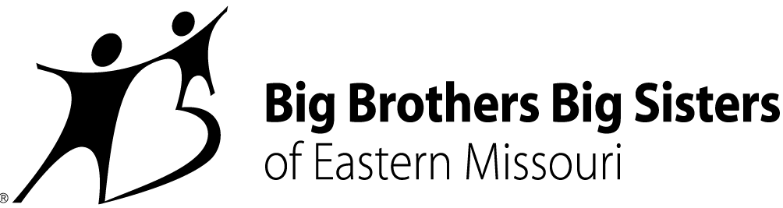

CONTACT:
Misty Willinger
Big Brothers Big Sisters of Eastern Missouri
Office: 314-633-0030
mwillinger@bbbsemo.org
Miya Norfleet-Aiken
Big Brothers Big Sisters of Eastern Missouri
Office: 314-615-1094
Mobile: 314-255-3444
media@bbbsemo.org

BIG BROTHERS BIG SISTERS OF EASTERN MISSOURI AND MISSOURI STATE UNIVERSITY
PARTNER ON NEW SCHOLARSHIP FOR LITTLE BROTHERS AND LITTLE SISTERS
St. Louis – August 5, 2019 – National mentorship leader Big Brothers Big Sisters of Eastern Missouri (BBBSEMO) is partnering with Missouri State University (MSU) to provide BBBSEMO “alumni” Little Brothers and Little Sisters attending MSU in Fall 2019 a chance to receive special financial support. Leaders of both entities will meet at BBBSEMO headquarters in St. Louis on Wednesday, August 7th at 4pm to make the partnership official.
The new Missouri State University/Big Brothers Big Sisters of Eastern Missouri Freshman Scholarship is an annual renewable award of $1,500 available to students nominated by BBBSEMO starting this year. High school seniors from St. Louis City and County, St. Charles County, and Cape Girardeau County who have been active with BBBSEMO for at least one year and in good standing with the agency during 12th grade will qualify for the award. Nominees also must meet Missouri State’s admission standards and enroll as full-time students the same year they complete high school.
Tashanna Rucker is Senior Director of Big Futures, an innovation launched by BBBSEMO five years ago expressly to support alumni Littles after graduation from Big Brothers Big Sisters’ traditional 1:1 match program. “Having worked at MSU in financial aid and scholarships in the past,” Rucker says, “I’m thrilled our BBBSEMO alumni at Missouri State will have a chance to experience its commitment to their success in this new way.”
The MSU/BBBSEMO scholarship joins another offered by Southeast Missouri University (SEMO) as a financial award for young people who are part of Big Brothers Big Sisters of Eastern Missouri. Like the SEMO scholarship, the MSU award goes beyond scholarship dollars by focusing on the overall student.
“MSU is home to a large number of first-generation and low-income students,” says Dr. Ryan Reed, MSU Coordinator of Access Programs, “so financial assistance is very important. But we also know that intentional, holistic support and guidance is absolutely critical, and that’s what we provide to help students get across the finish line with their degree.”
Missouri State President Clif Smart says the partnership between the university and BBBSEMO supports the university’s public affairs mission. “We’re excited for the opportunity to partner with Big Brothers Big Sisters of Eastern Missouri. We share a mission to help all students be successful in life. We believe access to a college education is part of what makes that possible.”
“Relationships are our work and our joy,” says BBBSEMO President and CEO Rebecca (Becky) J. Hatter, “and we know meaningful connection is key to the best possible college experience. We can’t wait to see how this innovative scholarship – itself the outgrowth of a budding relationship between BBBSEMO and MSU – helps our alumni Littles grow and flourish, too.”
MSU’s President Smart, Dr. Dee Siscoe (Vice President for Student Affairs), Mr. Ryan DeBeof (Chief of Staff), and Dr. Ryan Reed will travel from Springfield, MO to St. Louis on Wednesday to join BBBSEMO in signing a memorandum of understanding (MOU) at BBBSEMO’s 501 North Grand building in Grand Center. For more details about the signing, contact Tashanna Rucker by email (trucker@bbbsemo.org) or phone (314-633-0041).
About Big Brothers Big Sisters of Eastern Missouri (BBBSEMO)
Big Brothers Big Sisters of Eastern Missouri, founded in 1914 as a “charter” affiliate of Big Brothers Big Sisters of America, is guided by the principle that “In relationship, young people grow up with love, hope, and opportunity.” BBBSEMO’s approach includes five key elements: Create trusting, enduring relationships between young people (ages 5-25) and adult role models, mentors, and advocates; support academic success kindergarten to career; promote health and well-being; host life-skills training and development; coordinate temporary resources to support youth, parents, and families. The agency supports children and families in St. Louis City and County; St. Charles and Jefferson Counties; and Cape Girardeau and Scott Counties. Big Brothers Big Sisters of Eastern Missouri is a proud member of the United Way. For more information, contact Miya Norfleet (email - media@bbbsemo.org, phone - (314) 615-1094) or visit www.bbbsemo.org.

