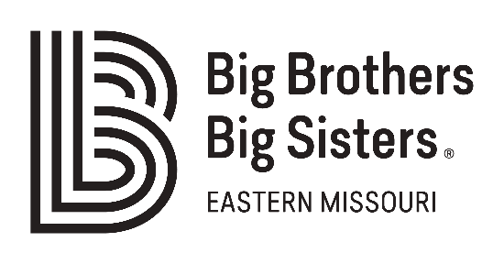

CONTACTS

Kristy Fairbanks
Big Brothers Big Sisters of Eastern Missouri
Mobile: 706-974-3673
kfairbanks@bbbsemo.org

Miya Norfleet
Big Brothers Big Sisters of Eastern Missouri
Mobile: 314-255-3444
media@bbbsemo.org

Big Brothers Big Sisters “Show Up for Youth” Volunteer Recruitment Campaign
Launches at Critical Time for Relationships with Kids, Especially Black Youth

ST. LOUIS – July 7, 2020 – Big Brothers Big Sisters of Eastern Missouri (BBBSEMO) is pulling out the stops to sign up over 300 volunteers – with at least 150 males among them – with its newly-launched “Show Up for Youth” campaign.

The agency’s efforts to specifically recruit Black male volunteers respond directly to BBBSEMO’s waitlist: Black boys ages 5-17 years old make up 80% of youth waiting to be matched with a Big Brother, Big Couple, or Big Family. Current events also demonstrate that mentoring and matching our region's youth is critical to supporting young people as they navigate a society plagued by systemic racism and social injustice.
Black Little Brothers can find unique supports in mentoring relationships with male volunteers of the same race, especially at this time.
“The COVID-19 pandemic and recent protests for justice continue to affect our Black community, and our youth need Bigs who can connect with them on a very personal level,” says BBBSEMO Director of Volunteer Recruitment Linda Robinson.

“Matches between Black Bigs and Littles promote positive racial identity, while letting young males know they matter,” Robinson adds. “That means improved social-emotional and mental health – and that’s an outcome with benefits for kids, families, adult volunteers, and the community alike.”
Along with Big Brothers, the sustained “Show Up for Youth” campaign is recruiting spouses and families to be Big Couple and Big Family matches, two options for men who’d like to be Bigs with their spouse and/or child(ren). Big Couples and Big Families are matched with Little Brothers due to the large number of boys on the waiting list.
“Show Up for Youth” recruitment will continue through the rest of 2020. To sign up to become a Big, visit www.bbbsemo.org/volunteer. For more information about how your organization can support the campaign, contact Linda Robinson at lrobinson@bbbsemo.org. To schedule an interview with Linda Robinson, key staff, or an active Big Brother, contact VP of Marketing & Experience Kristy Fairbanks at (314) 361-5900 or kfairbanks@bbbsemo.org.
About Show Up for Youth Campaign
“Show Up for Youth” is a broad, 6-month campaign to recruit all manner of volunteers across Eastern Missouri. This BBBSEMO effort will introduce a series of targeted “mini” campaigns focused by region (St. Louis City and County; St. Charles; Cape Girardeau), gender, and match options. A key “Show Up for Youth” feature is its call for community to extend reach to potential volunteers. BBBSEMO is seeking organizational and corporate partners – as well as individual advocates and allies – to promote “Show Up for Youth” among their respective networks through referrals, digital/social media shares, sponsorships, and more.
About Big Brothers Big Sisters of Eastern Missouri (BBBSEMO)
Big Brothers Big Sisters of Eastern Missouri serves youth and community since 1914. With over 1,400 active matches in its one-to-one mentoring program, youth outcomes are improved. Its one-to-many initiatives broaden the scope of service and include the ABCToday initiative in 19 schools; its Big Futures program serving alumni Littles ages 18-25; and its community-gathering space at Anew. The agency supports children and families in St. Louis City and County; St. Charles and Jefferson Counties; and Cape Girardeau and Scott Counties. Big Brothers Big Sisters of Eastern Missouri is a proud member of the United Way. For more information, contact Miya Norfleet (email - media@bbbsemo.org, phone - 314-255-3444) or visit www.bbbsemo.org.

